Navigation Bar with Dropdown:

<li class="nav-item dropdown">  
  <a class="nav-link dropdown-toggle" href="#"data-bs-toggle="dropdown">Dropdown</a>  
  <ul class="dropdown-menu">  
    <li><a class="dropdown-item" href="#">Link</a></li>  
    <li><a class="dropdown-item" href="#">Another link</a></li>  
    <li><a class="dropdown-item" href="#">A third link</a></li>  
  </ul>  
</li>

DropDown:

* The .dropdown class indicates a dropdown menu.
* To open the dropdown menu, use a button or a link with a class of .dropdown-toggle and the data-bs-toggle="dropdown" attribute.
* Add the .dropdown-menu class to a <div> element to actually build the dropdown menu. Then add the .dropdown-item class to each element (links or buttons) inside the dropdown menu.

Bootstrap Collapse:

* The .collapse class indicates a collapsible element (a <div> in our example); this is the content that will be shown or hidden with a click of a button.
* To control (show/hide) the collapsible content, add the data-bs-toggle="collapse" attribute to an <a> or a <button> element. Then add the data-bs-target="#id" attribute to connect the button with the collapsible content (<div id="demo">).

<button data-bs-toggle="collapse" data-bs-target="#demo">Collapsible</button>  
<div id="demo" class="collapse">  
Lorem ipsum dolor text....  
</div>

**Collapsive NaveBar**:

<nav class="navbar navbar-expand-sm bg-dark navbar-dark">  
  <div class="container-fluid">  
    <a class="navbar-brand" href="#">Logo</a>  
    <button class="navbar-toggler" type="button" data-bs-toggle="collapse" data-bs-target="#collapsibleNavbar">  
      <span class="navbar-toggler-icon"></span>  
    </button>  
    <div class="collapse navbar-collapse" id="collapsibleNavbar">  
      <ul class="navbar-nav">  
        <li class="nav-item">  
          <a class="nav-link" href="#">Link</a>  
        </li>  
        <li class="nav-item">  
          <a class="nav-link" href="#">Link</a>  
        </li>  
        <li class="nav-item">  
          <a class="nav-link" href="#">Link</a>  
        </li>  
      </ul>  
    </div>  
  </div>  
</nav>

BOOTSTRAP FORMS:

1)

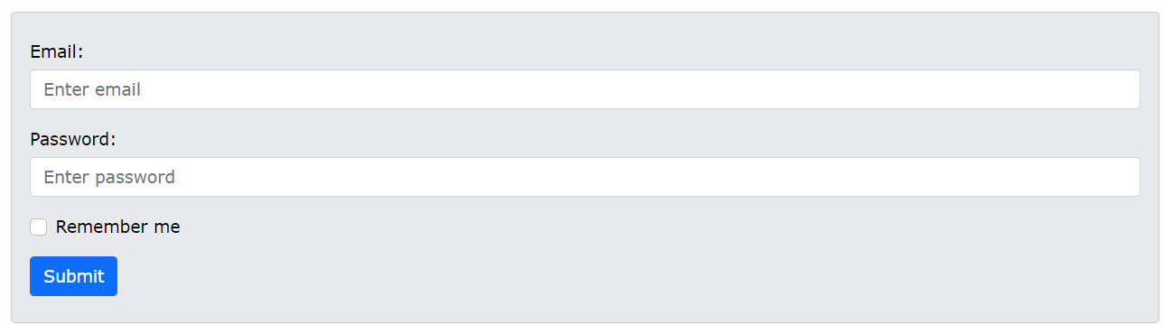

<form action="/action_page.php">  
  <div class="mb-3 mt-3">  
    <label for="email" class="form-label">Email:</label>  
    <input type="email" class="form-control" id="email" placeholder="Enter email" name="email">  
  </div>  
  <div class="mb-3">  
    <label for="pwd" class="form-label">Password:</label>  
    <input type="password" class="form-control" id="pwd" placeholder="Enter password" name="pswd">  
  </div>  
  <div class="form-check mb-3">  
    <label class="form-check-label">  
      <input class="form-check-input" type="checkbox" name="remember"> Remember me  
    </label>  
  </div>  
  <button type="submit" class="btn btn-primary">Submit</button>  
</form>

Note:

* That we add a .form-label class to each label element to ensure correct padding.
* Checkboxes have different markup. They are wrapped around a container element with .form-check, and labels have a class of .form-check-label, while checkboxes and radio buttons use .form-check-input.

Text Area:

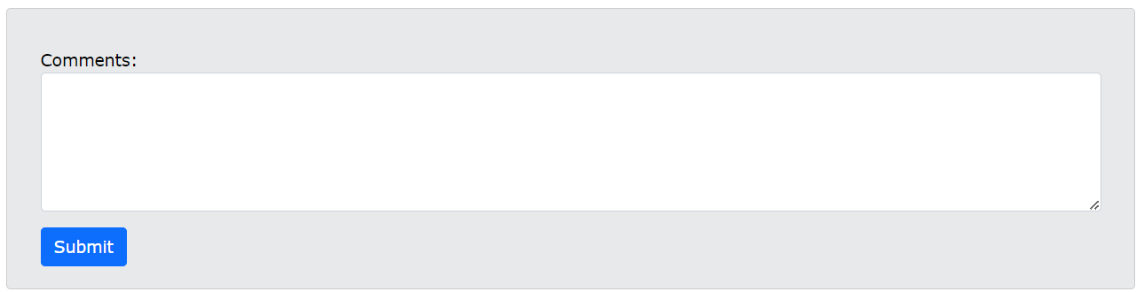

<label for="comment">Comments:</label>  
<textarea class="form-control" rows="5" id="comment" name="text"></textarea>

Inline Forms:

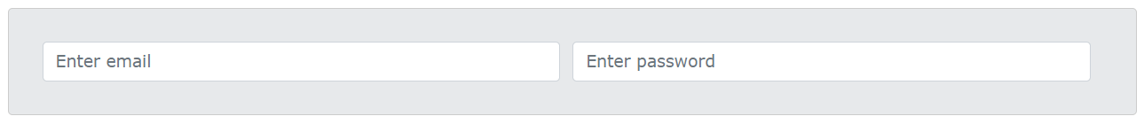

<form>  
  <div class="row">  
    <div class="col">  
      <input type="text" class="form-control" placeholder="Enter email" name="email">  
    </div>  
    <div class="col">  
      <input type="password" class="form-control" placeholder="Enter password" name="pswd">  
    </div>  
  </div>  
</form>

**FORM CONTROL:**

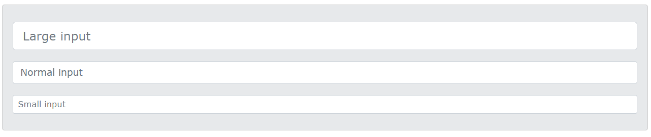

<input type="text" class="form-control form-control-lg" placeholder="Large input">  
<input type="text" class="form-control" placeholder="Normal input">  
<input type="text" class="form-control form-control-sm" placeholder="Small input">